Technical Architecture Technical Architecture – DocSpot

Date | 03 February 2026
Team ID | LTVIP2026TMIDS24613
Project Name | DocSpot: Seamless Appointment Booking for Health
Maximum Marks | 4 Marks

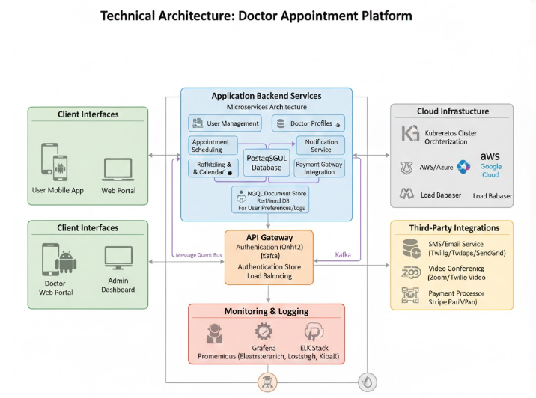

DocSpot adopts a modular and scalable 3-tier architecture that ensures separation of concerns, maintainability, and performance. Each layer works independently while communicating through secure and efficient APIs.

Presentation Layer (Frontend)
  - Purpose: Acts as the user interface for all roles—patients, doctors, and admins.
  - Technology Stack: React.js, HTML, CSS, JavaScript, Bootstrap/Tailwind CSS

Responsibilities:
    - Render responsive and dynamic UI
    - Provide role-based dashboards
    - Handle form inputs, document uploads, appointment booking
    - Communicate with backend via RESTful APIs using Axios

Business Logic Layer (Backend)
  - Purpose: Implements the application’s core logic and enforces workflows.
  - Technology Stack: Node.js, Express.js, JWT, Multer

Responsibilities:
    - User authentication and authorization (JWT)
    - Appointment management and scheduling validations
    - Doctor profile approval and role-based routing
    - Admin operations, document handling, and notifications
    - REST API endpoints to serve frontend requests

Data Storage Layer
  - Purpose: Stores and manages application data securely and efficiently.
  - Technology Stack: MongoDB, Mongoose

Responsibilities:

    - Manage collections for Users, Appointments, Documents,
Notifications
    - Maintain relationships between patients, doctors, and appointments
    - Ensure data integrity, indexing for fast queries, and schema validation
Additional Integrations
  - Email/SMS API (e.g., Nodemailer, Twilio): For sending appointment confirmations and reminders.
  - Telehealth API (optional): To support video consultations.
  - Authentication Middleware: Secure access to protected routes.
  - File Handling: Upload and retrieve prescriptions or medical records using Multer and MongoDB (or cloud storage in future phases).

Components & Technologies – DocSpot

S.No | Component | Description | Technology Used
1 | User Interface | Web-based responsive UI | React.js, HTML, CSS,
 |  | for patients, doctors, and | JavaScript, Bootstrap,
 |  | admins | Tailwind CSS
2 | Routing & | Handles client-side page | React Router DOM,
 | Navigation | switching and protected | Context API
 |  | routes
3 | API | Facilitates frontend- | Axios (HTTP client)
 | Communication | backend interaction
4 | Authentication | Secure login and role | JSON Web Tokens (JWT),
 | System | management | bcrypt.js
5 | Appointment | Booking, status | Node.js, Express.js
 | Logic | management, and slot
 |  | scheduling
6 | Admin Panel | Doctor approval, user | React.js (admin views),
 |  | management, and | Express.js (backend
 |  | appointment oversight | logic)
7 | Database | Stores users, doctors, | MongoDB, Mongoose
 | Management | appointments, and
 |  | reviews
8 | Document | Uploading and accessing | Multer (middleware),
 | Uploads | prescriptions or reports | MongoDB (GridFS or
 |  |  | binary storage)
9 | Notifications | Alerts for appointment | Email (Nodemailer),
 | System | status or changes | optional SMS (Twilio)

10 Deployment & Hosting
Making the app available online
Vercel (frontend), Render or Cyclic (backend)

11 Version Control & Source code management
CI/CD
and deployment pipeline
(optional)
Git, GitHub, GitHub
Actions

DocSpot – Application & Characteristics
S.No Application Module

Key Characteristics

1 | User Interface (UI) | Responsive, role-based design using  React.js; mobile-friendly and intuitive
2 | User | JWT-based login system with role
 | Authentication | verification for patients, doctors, and
 |  | admins
3 | Appointment | Real-time slot availability, status tracking
 | Booking | (pending/approved/completed)
4 | Doctor Profile | Editable profiles with specialization,
 | Management | availability, and experience info
5 | Admin Panel | Doctor approval, user management, and
 |  | platform analytics
6 | Notification | SMS/Email alerts for appointment
 | System | confirmations, reminders, and status
 |  | updates
7 | Document Upload | Patients can upload prescriptions/reports;
 |  | doctors can access pre-appointment
 |  | documents
8 | Teleconsultation | Optional video consultations via
 | Module | integrated APIs (future enhancement)
9 | Review & Rating | Patients can leave feedback after each
 | System | appointment
10 | Data Storage & | MongoDB with schema validation,
 | Security | encrypted user data, and role-based
 |  | access control

